Perform the following questions on people.json data:

1.Count number of records

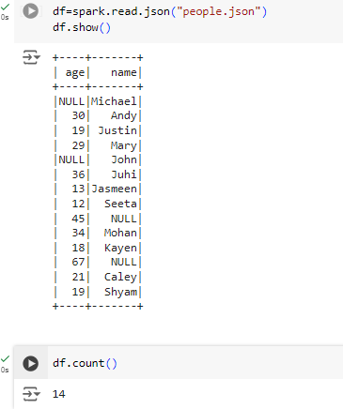

2.create a new column with a simple copy of the age column.

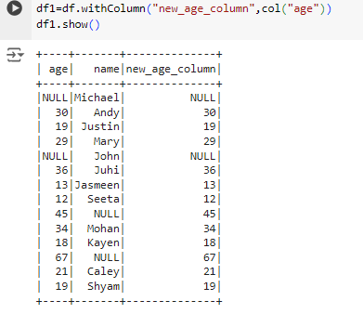

3.create a new column containing ages of people one year bigger.

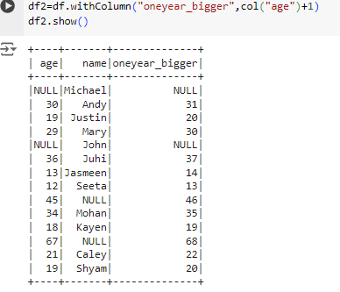

4.Show the records where age column is missing.

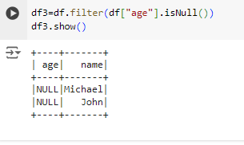

5.Fetch the records having atleast one non-null values.

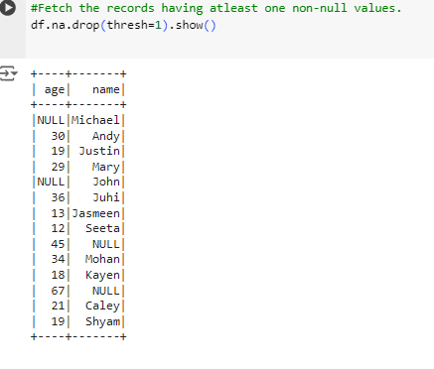

6.Fill the missing values of age column with mean

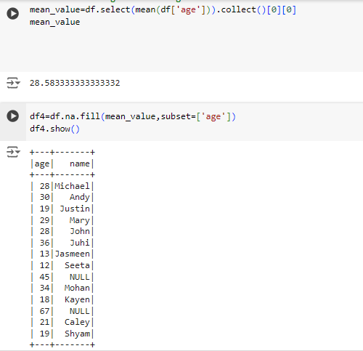

7.Write a sql query to find the people with age greater than 19.

